**DEPARTMENT OF MECHANICAL ENGINEERING  
  
Subject: Fundamentals of Programming  
Lab MANUAL: 8  
Submitted by: Omar Mudassar  
Registration number: 465779  
Semester No. 1  
Date: December 3, 2023**

**FIRST TASK**

#include<iostream>

using namespace std;

int main()

{

int z;

cout<<"Enter number of elements "<<endl;

cin>>z;

cout<<"Enter Elements "<<endl;

int arr[z];

for(int i=0;i<z;i++){

cin>>arr[i];

}

int count=0;

cout<<"Repeating elements are "<<endl;

for(int i=0;i<z;i++){

for(int j=i+1;j<z;j++){

if(arr[i]==arr[j]){

cout<<arr[j]<<" ";

}

}

}

return 0;

}

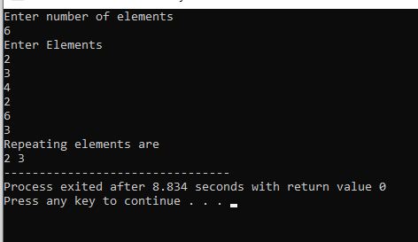

**SECOND TASK**

#include<bits/stdc++.h>

using namespace std;

int main() {

int len=8, a[len] = {89, 12, 34, 3, 102, 77, 65, 43};

int larger, smaller;

larger = a[1];

smaller = a[1];

for (int i=0; i<len; i++) {

if (larger < a[i])

larger = a[i];

if (smaller > a[i])

smaller = a[i];

}

cout<<"Largest element is: "<<larger<<endl;

cout<<"Smallest element is: "<<smaller;

return 0;

}

**THIRD TASK**

#include<bits/stdc++.h>

using namespace std;

int main() {

int len=5, nums[len], temp;

for (int i=0; i<len; i++) {

cout<<"Enter element "<<i+1<<": ";

cin>>nums[i];

}

temp = nums[1];

nums[1] = nums[3];

nums[3] = temp;

cout<<"Swapped array is: {";

for (int i=0; i<len; i++) {

cout<<nums[i];

if (i==len-1)

continue;

cout<<", ";

}

cout<<"}";

return 0;

}

